Instituto Superior Técnico

Distributed Predictive Control and Estimation

MEEC

Laboratory Report -

2nd Semester – 4th Quarter – 2024/2025

**Grupo: 18**

**Authors:**

Alexandre Leal (103098)alexandre.leal@tecnico.ulsiboa.pt

Diogo Sampaio (103068) diogo.sampaio@tecnico.ulisboa.pt

Francisco Tavares (103402)

Marta Valente (103574)

[francisco.carreira.tavares@tecnico.ulisboa.pt](mailto:francisco.carreira.tavares@tecnico.ulisboa.pt)

[marta.valente@tecnico.ulisboa.pt](mailto:marta.valente@tecnico.ulisboa.pt)

## **P1 – Basic on Constrained Optimization**

For the vector , the Rosenbrock function is defined as:

As illustrated in Figure 1, the Rosenbrock function exhibits a narrow and curved valley, with a unique global minimum at:

,

The goal of this task is to find this minimum numerically using MATLAB, both without and with constraints, and to visualise the results using meaningful graphical outputs.

**Unconstrained Minimum**

Since the function is non-negative, any point where must be a global minimiser. Setting each squared term in to zero yields:

This is the only stationary point, confirmed by evaluating the gradient:

We applied the quasi-Newton method via MATLAB’s *fminunc*, starting from:

The optimisation converged to:

Which closely matches the theoretical minimum.

**Constrained Minimum**

Next, we impose a constraint on the search space:

With no stationary points inside the feasible region, the constrained minimiser must lie on the boundary . Using the Lagrange multipliers method with:

We solve:

Numerical confirmation with *fmincon* (initial guess ) returned:

This result confirms the expected theoretical solution.

**Graphical Interpretation**

To better understand the effect of the constraint, three figures were generated:

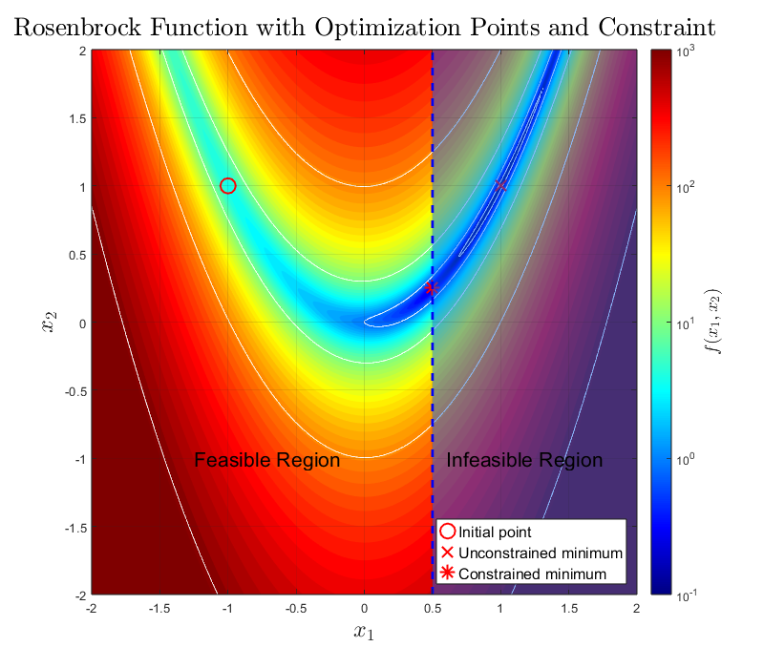

Figura 1: Optimization Points and Constraint.

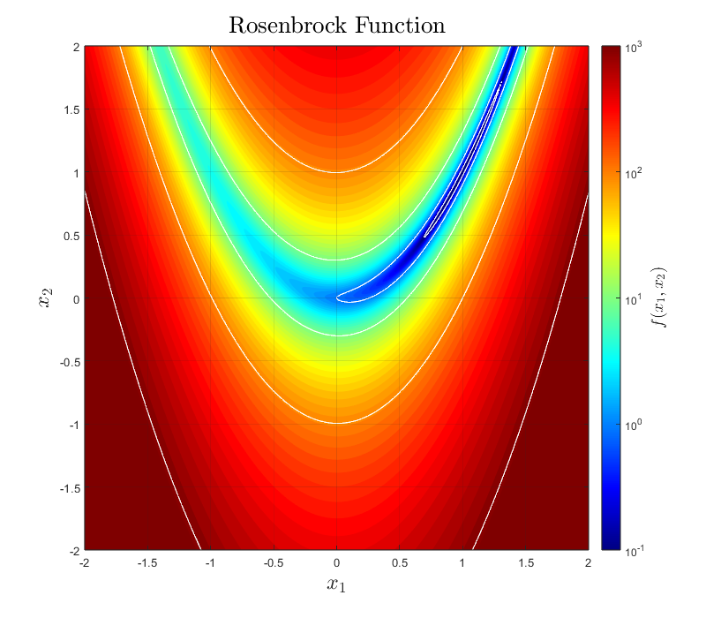

Figura 2: Heatmap and Contours.

Figure 1 represents a logarithmic heatmap of the Rosenbrock function with white level curves. This plot displays only the function shape, without points or annotations. Figure 2 shows the initial point (o), unconstrained solution (x), and constrained solution (*), along with the shaded infeasible region and its dashed boundary.

Figure 3 is a 3D plot of the Rosenbrock function surface, displaying the valley that leads to the global minimum.

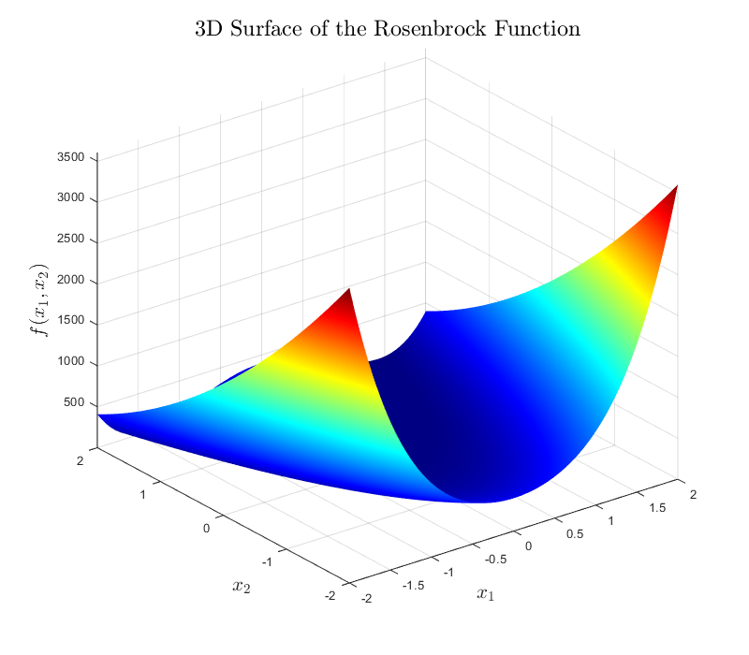

Figura 3: 3D Surface Plot.

## **P2 – Basic on Receding Horizon Control**

## **P3 – Model Identification**

## **P4 – MPC and Kalman Filter Design**

## **P5 – Application to the Real System**